IMPORTANT Update from Mother Clare 1 of 2
November 7th, 2024

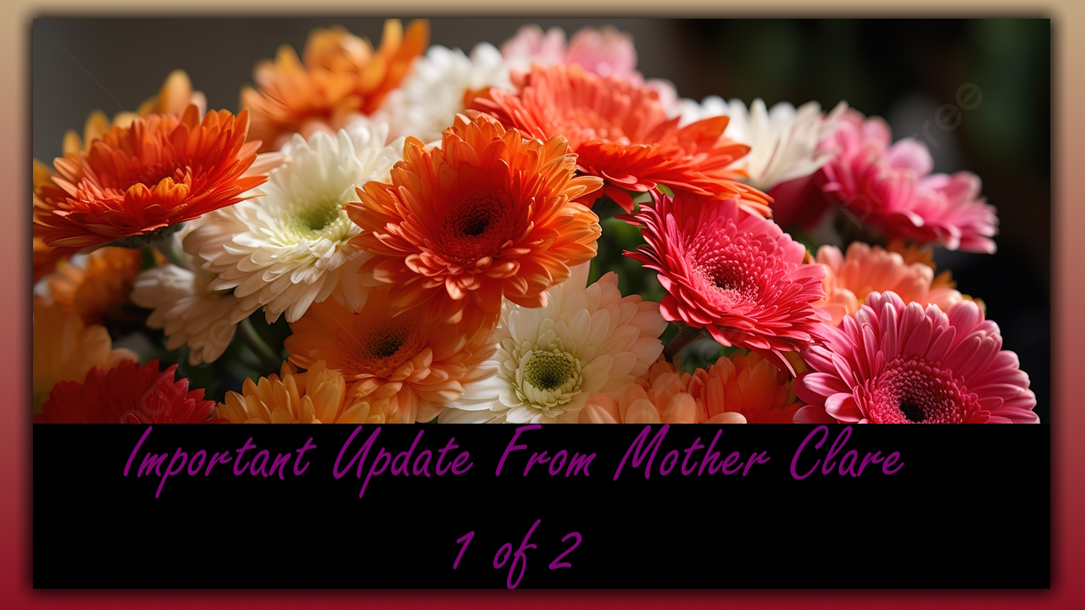
My precious heart dwellers, I Want you to know that our channel has been under very heavy attacks.

There's been sickness. There's been equipment failure.

We'd have difficulty putting up messages for two weeks. It took hours and hours for the messages to get up on the channel. So, we're way behind on where we should be. I Was taking Mike three hours just to get a message up and sometimes at the last minute, it would fail, and he'd have to start all over again. So, it's very disheartening.

But I want you to understand why the channel hasn't been running smoothly. It's kind of jumbled up and messed up right now because we're trying to bring forward the messages we had even from last month that somehow got overlooked.

And I wanted you to know that we've been not doing exactly what I want to do during this time. I was in the hospital with an animal bite for five days and, and that kind of threw things into a loop because I didn't know where everything was.

Well, whether it was in line to get published whether it was in the proper order, so please forgive me for having a messed up channel and as the Lord has told me before, He wants me to start putting out more things about the bride and now I am having experiences with him in heaven and I'm going to be able to share those with you.

So that's the good news and what I'm asking for here would you please be patient with me and understand that we went through a really rough time?

For the last month or so and that's why the messages are kind of mixed up so what we're going to do because this is so important to me that you get all the messages right away within one day. So, they are in the proper order and context, we're going to have the messages that are current, and the word current will be at the end of the sentence, the title.

Okay, so we will mark the messages that are timely for you to read now for you to hear now we'll mark those new and the other ones we will mark “backlog”, so you understand what's what and I highly recommend that you listen to the new ones first.

And then if you want to listen to the backlog, that's fine.

Okay, so that said I hope that will straighten out any confusion that you've had over the order of the messages.

I'm doing much better. I'm fine and everyone here is doing their job. It's just a matter, well, it's fun to get out and shovel snow, right?

Thank the Lord we have we have helped with that I guess we've got about a foot now, but the channel will keep going we're not under the weather that won't prevent us from getting messages up in a timely manner.
And then the other thing is I wanted to switch the subject more into the bridal intimacy type messages
to give you a place to escape to and to think about heaven and to draw out of the chaos in the world and the darkness in the world and have a place to rest.

That's all about heaven So that will be what our new messages are about after this one is posted and I hope you enjoy them.

